DOMBEYA

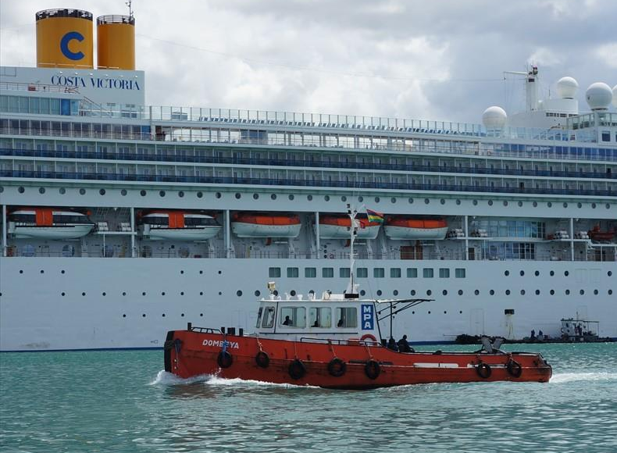

IMO: 9157882
Call Sign: -
Flag: -
AIS Vessel Type: Tug
Gross Tonnage: 41
Deadweight: -
Length Overall x Breadth Extreme: 16.89m × 5.29m
Year Built: 1999
Status: Active

