SIR GAETAN

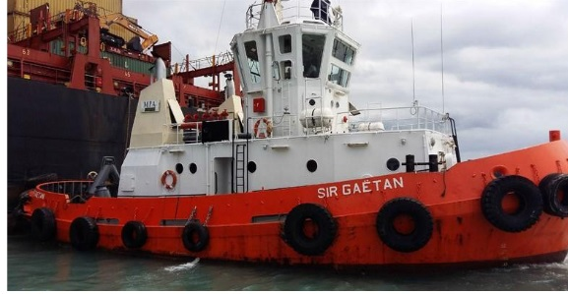

IMO: -
MMSI: 645443000
Call Sign: 3BIM
Flag: Mauritius [MU]
AIS Vessel Type: Tug
Gross Tonnage: -
Deadweight: -
Length Overall x Breadth Extreme: N/a
Year Built: -
Status: Active

