MAHE DE LABOURDONNAIS
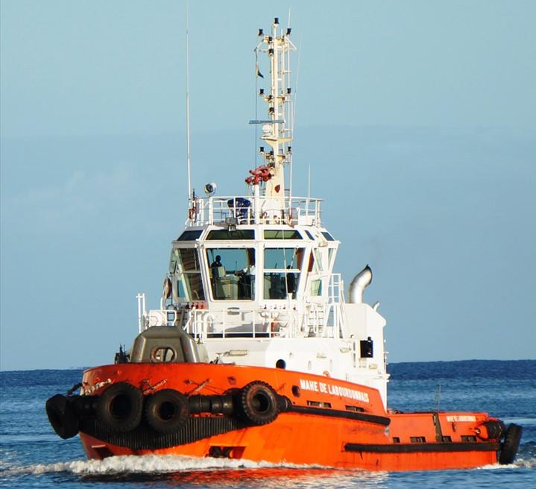

IMO: 9209441
MMSI: 645166000
Call Sign: 3BLS
Flag: Mauritius [MU]
AIS Vessel Type: Tug
Gross Tonnage: 275
Deadweight: 160 t
Length Overall x Breadth Extreme: 26m × 9.3m
Year Built: 2001
Status: Active

