SIR SEEWOOSAGUR

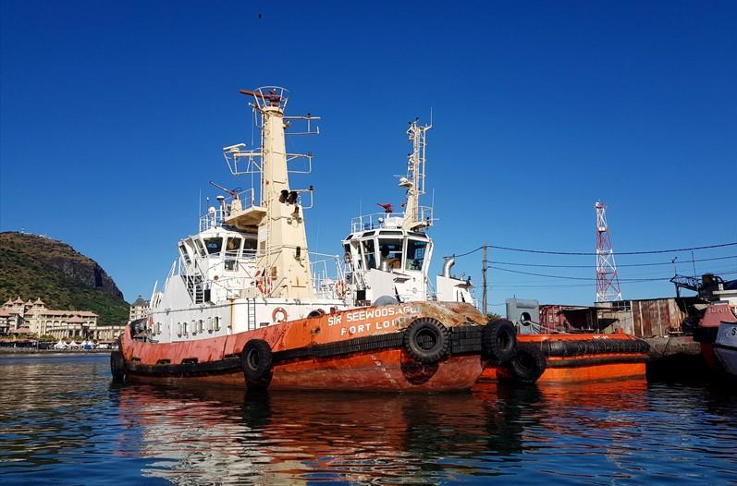

IMO: 8608432
Call Sign: -
Flag: -
AIS Vessel Type: Tug
Gross Tonnage: 254
Deadweight: 174 t
Length Overall x Breadth Extreme: 29.25m × 9m
Year Built: 1987
Status: Active

