DA PATTEN
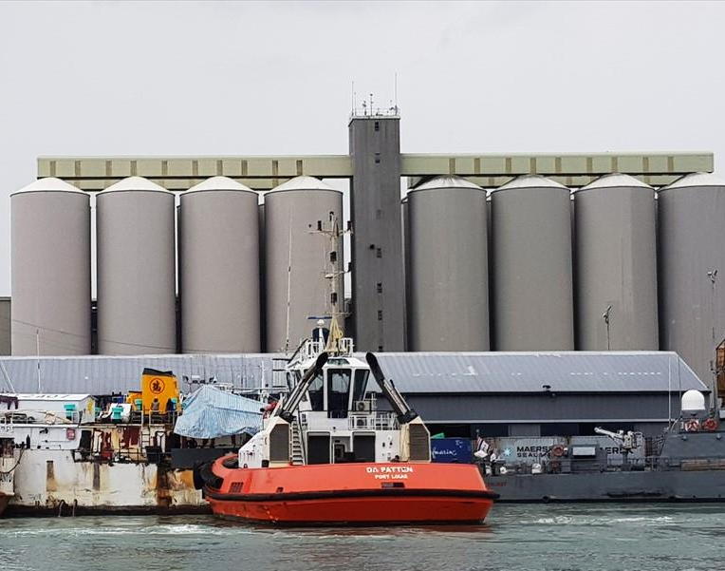

IMO: 9460710
MMSI: 645301000
Call Sign: 3BQZ
Flag: Mauritius [MU]
AIS Vessel Type: Unspecified
Gross Tonnage: 192
Deadweight: 150 t
Length Overall x Breadth Extreme: 24.55m × 10.7m
Year Built: 2009
Status: Active

